**1. Create a sequence for populating the Customer# column of the CUSTOMERS table. When setting the start and increment values, keep in mind that data already exists in this table.**

**The options should be set to not cycle the values and not cache any values, and no  
minimum or maximum values should be declared.**

CREATE SEQUENCE customers_customer#_seq

INCREMENT BY 1

START WITH 10

NOCACHE

NOMINVAULE

NOMAXVALUE

NOCYCLE;

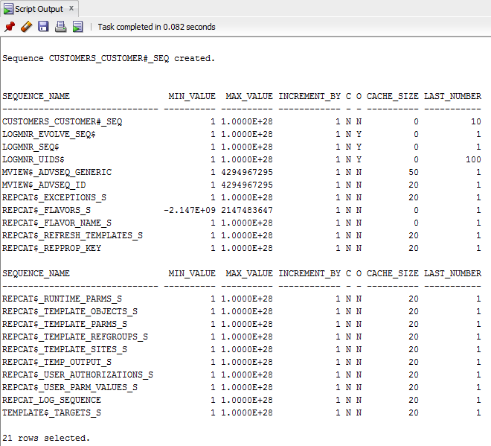

**2. Add a new customer row by using the sequence created in Question 1. The only data  
currently available for the customer is as follows: last name = Shoulders, first name =  
Frank, and zip = 23567.**

INSTER INTO CUSTOMERS (customer#, lastname, firstname, zip)

VALUES(customers_customer#_seq.NEXTVAL, 'Shoulders', 'Frank', 23567);

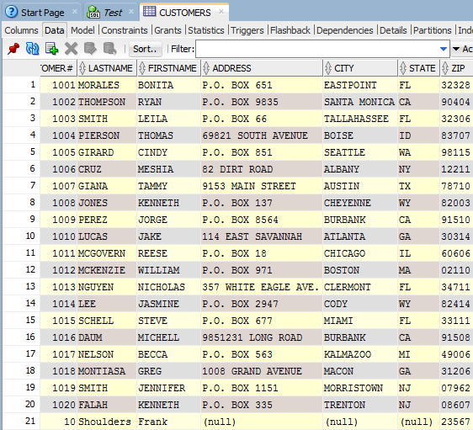

**3. Create a sequence that generates integers starting with the value 5. Each value should be three less than the previous value generated. The lowest possible value should be 0, and the sequence shouldn’t be allowed to cycle. Name the sequence MY_FIRST_SEQ.**

CREATE SEQUENCE my_first_seq

INCREMENT BY -3

START WITH 5

MINVALUE 0

MAXVALUE 5

NOCYCLE;

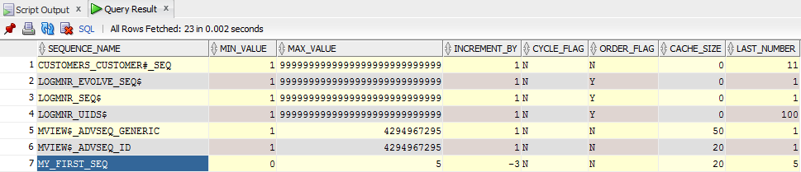

**4. Issue a SELECT statement that displays NEXTVAL for MY_FIRST_SEQ three times.  
Because the value isn’t being placed in a table, use the DUAL table in the FROM clause of the SELECT statement. What causes the error on the third SELECT?**

SELECT MY_FIRST_SEQ.NEXTVAL

FROM dual;

SELECT MY_FIRST_SEQ.NEXTVAL

FROM dual;

SELECT MY_FIRST_SEQ.NEXTVAL

FROM dual;

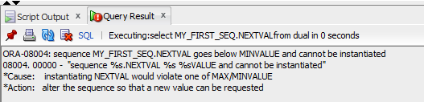

**5. Change the setting of MY_FIRST_SEQ so that the minimum value that can be generated is –1000.**

ALTER SEQUENCE my_first_seq

MINVALUE -1000;

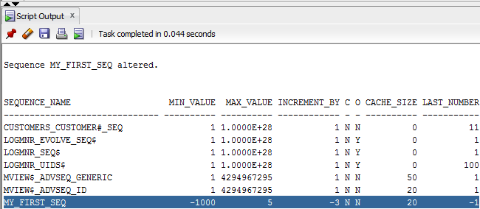

**6. A new table has been requested to support tracking automated emails sent to customers.  
Create the table and add data as described below.  
• Tablename: email_log  
• Columns: emailid (numeric), emaildate (datetime), customer# (numeric)  
• Primary key: emailid column, define as an Identity Column  
• Add the following data rows and display resulting rows (if any errors occur, explain  
why the error is expected)**

**1. Emaildate = current date, customer# = 1007  
2. Emailid = specify to use the column default value, emaildate = current date, customer# = 1008  
3. Emailid = 25, emaildate = current date, customer# = 1009**

CREATE TABLE "email_log"

(emailid NUMBER (20),

emaildate DATE,

customer# NUMBER (15),

CONSTRAINT emailid_pk PRIMARY KEY (emailid));

INSERT INTO "email_log" (emaildate, customer#)

VALUES (?, SYSDATE, 1007);

INSERT INTO "email_log" (emailid, emaildate, customer#)

VALUES (?,SYSDATE, 1008);

INSERT INTO "email_log" (emailid, emaildate, customer#)

VALUES (25, SYSDATE, 1009);

**7. Create a private synonym that enables you to reference the MY_FIRST_SEQ object as NUMGEN.**

CREATE SYNONYM numgen

FOR my_first_seq;

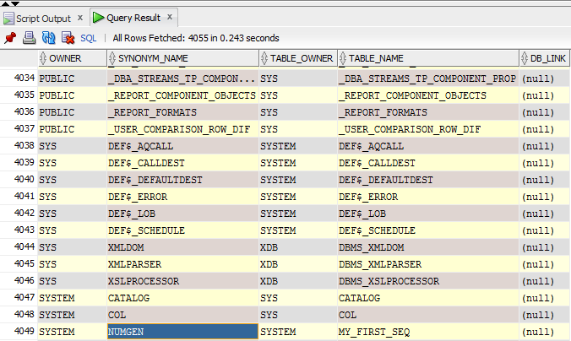

**8. Use a SELECT statement to view the CURRVAL of NUMGEN. Delete the NUMGEN  
synonym and MY_FIRST_SEQ.**

SELECT numgen.CURRVAL

FROM DUAL;

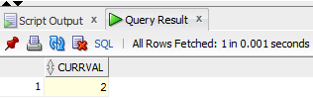

DROP SYNONYM numgen;

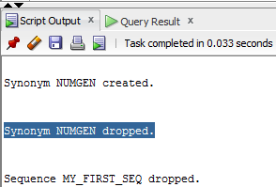

DROP SEQUENCE my_first_seq;

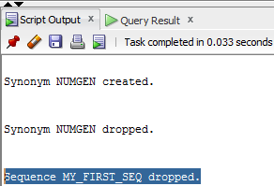

**9. Create a bitmap index on the CUSTOMERS table to speed up queries that search for  
customers based on their state of residence. Verify that the index exists, and then delete the index.**

CREATE BITMAP INDEX cust_state_bit

ON customer(state);

SELECT index_name

FROM user_indexes;

DROP INDEX cust_state_bit;

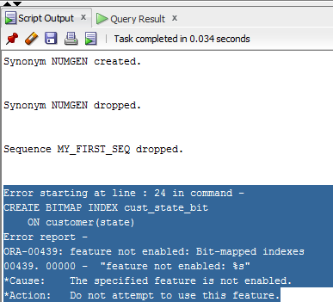

**10. Create a B-tree index on the customer’s Lastname column. Verify that the index exists by querying the data dictionary. Remove the index from the database.**

CREATE INDEX cust_lname_index

ON customers(lastname);

SELECT index_name

FROM user_indexes;

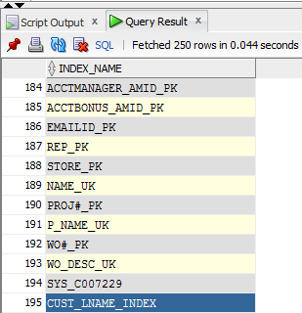

DROP INDEX cust_lname_index;

**11. Many queries search by the number of days to ship (number of days between the order and shipping dates). Create an index that might improve the performance of these queries.**

CREATE INDEX num_days_ship

ON orders(shipdate-orderdate);

